9. Ethyl chloride on heating with silver cyanide forms a compound X (major). The functional isomer of X is



10. Which of the following is the correct formula of dichlorodiphenyl trichloroethane?

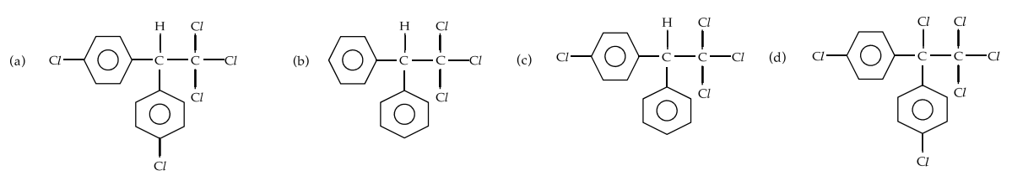

11.

**,………………………….,**

12. 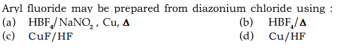

13. Which is not the Wurtz-Fittig reaction?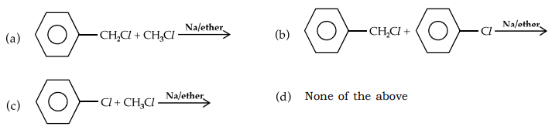

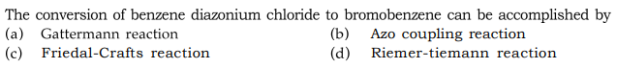14.

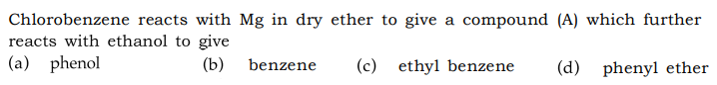15.



16.



17.

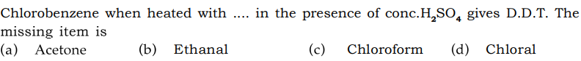

18.

19. 

20.